* **Lab Task 1:**

Display the ID and name of countries that have no airports located in them.

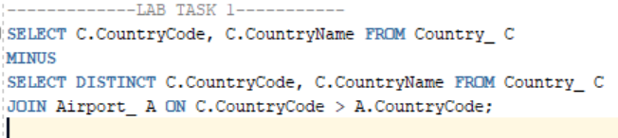

OUTPUT:

